______________________________________________________________________________

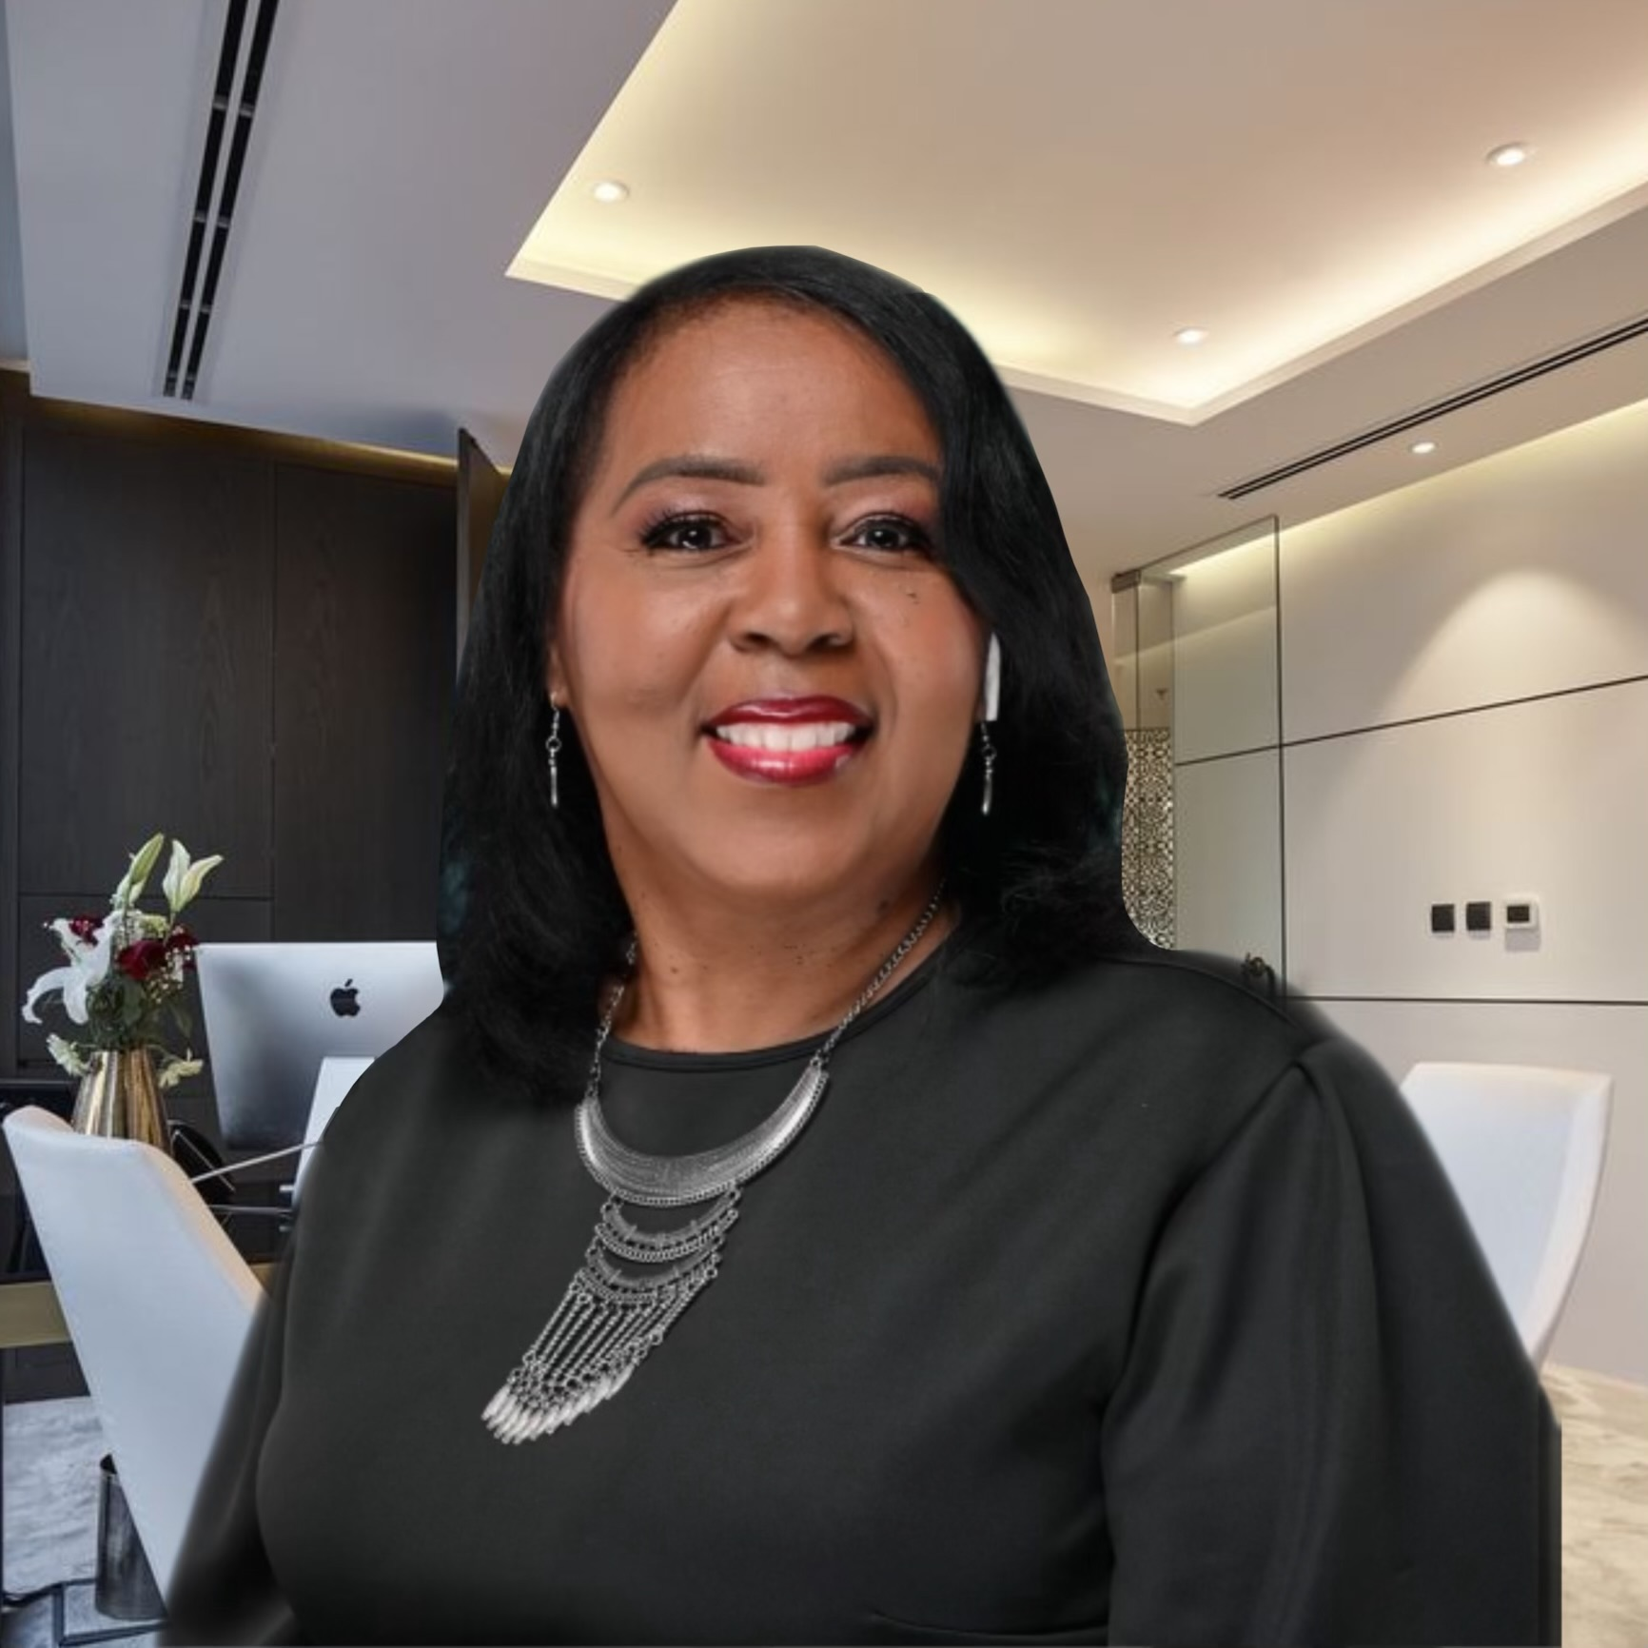

Dr. Karen Doughty

Ambassador for Change • Christian Therapist • Transformational Speaker
Founder of Woman Rise & Karen Doughty Counseling

Dr. Karen Doughty is a dynamic and inspiring speaker who blends faith, psychology, and personal transformation to help individuals heal from trauma and step into their divine purpose. As a licensed Christian therapist and biblical psychologist, she specializes in guiding individuals through emotional and spiritual restoration. With years of experience in trauma recovery, including sexual abuse healing and domestic violence awareness, she empowers audiences with messages of hope, healing, and purpose.
……………………….
Testimonials
Speaking Topics
“I think you did a beautiful job spelling out the struggle, the deliverance, and hope for the future. Thanks so much.
Timiko Ilion, LPC-S, NCC
Licensed Professional Counselor/ MST Co-Coordinator
__________________________
"You are "awesome!" I saw first-hand, women absorbing your message and following your journey as if they were there with you.

-Laura Balthazar, Executive Director

- Learning to Believe in Yourself – Empowering you to overcome self-doubt, embrace your worth, and walk confidently in your purpose."
- Domestic Violence: Love Is Not Supposed to Hurt – Breaking the cycle of abuse and reclaiming self-worth.
- Overcoming Child Sexual Abuse – A journey of healing from past wounds.

WHY BOOK DR. KAREN DOUGHTY?
- Authentic & Engaging Speaker – Uses real-life stories to inspire and empower.
- Customized Presentations – Tailored messages to meet the unique needs of any audience.

🌍www.karendoughty.org • 📞225-223-9107 • 📧 DrD@karendoughty.org

